Project N0 3:- IOT Based Garbage monitoring system

One of the main concerns with our environment has been solid waste management which impacts the health and environment of our society. The detection, monitoring and management of wastes is one of the primary problems of the present era. The traditional way of manually monitoring the wastes in waste bins is a cumbersome process and utilizes more human effort, time and cost which can easily be avoided with our present technologies.
This is our solution, a method in which waste management is automated. This is our IoT Garbage Monitoring system, an innovative way that will help to keep the cities clean and healthy.

Component Required:-

- Node MCU
- Ultrasonic Sensor
- Jumper cables
- 2.2K and 4.7K Resistor

Circuit Diagram:-
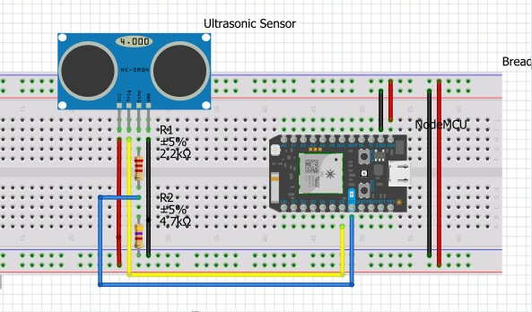

Installing Drivers and Libraries Necessary
To be able to program the Node MCu, you need to first install the drivers. To check if you already have them installed open the arduino IDE, click on tools then boards and look if either node MCU 1.0(ESP-12E Module) are in the list. If they are there skip to next step, if not follow along...

To download the necessary drivers to be able to use Node MCU, open the arduino IDE again, click on tools, boards, then boards manager.

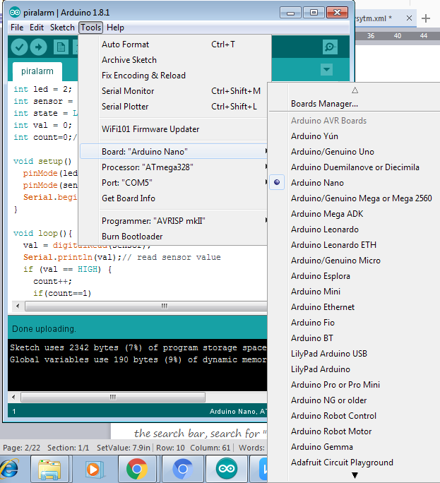
Now in the search bar, search for "Node MCU", select your arduino IDE version and download the one that comes (double check with the picture below)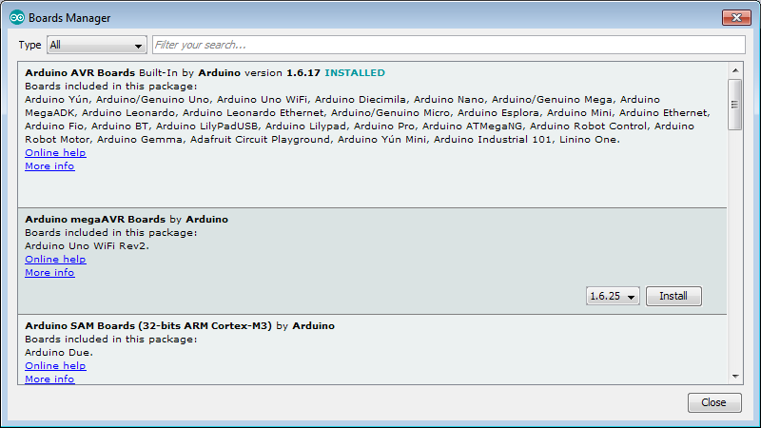

Nowin the search bar, search for blynk and ultrasonic, choose your IDE version and install. (double check with the pictures below)

Intro to Blynk App
To connect to the internet we use a prebuilt platform called blynk, which can be downloaded from the android play store, link below...There are countless examples on how to use the app with the arduino which are all available by heading to files in the arduino IDE, then examples and under the blynk list.
link to blynk app : https://play.google.com/store/apps/details?id=cc....
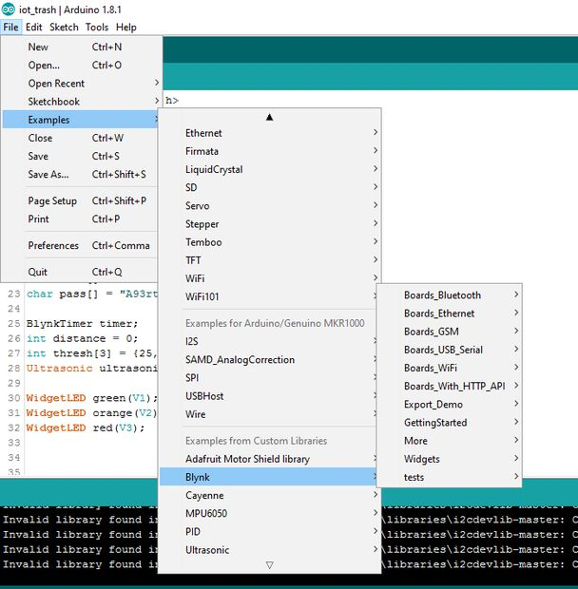

SETTING UP THE APP & CODE
Once you are familiar with blynk and how it works, you can upload the program attached below. Some things you have to change in the program are :
- replace "wifi id" in line 22, with your actual wifi id
- replace "password" in line 23 with your actual wifi password
- replace "auth token" in line 18 with your blynk's authorization token which u should have received through mail while installing blynk
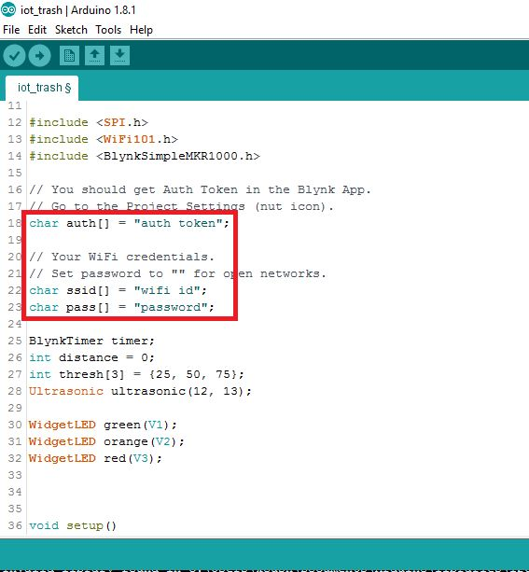
Make sure you have the right board type selected (Node MCU 12E)and the correct port. To setup the Blynk interface you need to use three virtual LEDs, lined up one on top of the other. (follow the picture below)

Source Code:-
#include < ESP8266WiFi.h>#include < Servo.h>Servo servo;
const char* ssid = "Your SSID";
const char* password = "Your Wifi Password";
WiFiServer server(80);
void setup() {
Serial.begin(115200);
delay(10);
servo.attach(1); //Gpio-2 of nodemcu with pwm pin of servo motor
// Connect to WiFi network
Serial.println();
Serial.println();
Serial.print("Connecting to ");
Serial.println(ssid);

WiFi.begin(ssid, password);

while (WiFi.status() != WL_CONNECTED) {
delay(500);
Serial.print(".");
}
Serial.println("");
Serial.println("WiFi connected");

// Start the server
server.begin();
Serial.println("Server started");

// Print the IP address on serial monitor
Serial.print("Use this URL to connect: ");
Serial.print("http://"); //URL IP to be typed in mobile/desktop browser
Serial.print(WiFi.localIP());
Serial.println("/");
}
void loop() {
// Check if a client has connected
WiFiClient client = server.available();
if (!client) {
return;
}

// Wait until the client sends some data
Serial.println("new client");
while(!client.available()){
delay(1);
}

// Read the first line of the request
String request = client.readStringUntil('\r');
Serial.println(request);
client.flush();

int value = 0;
// Match the request
if (request.indexOf("/Req=0") != -1) {
servo.write(0); //Moving servo to 0 degree
value=0;}if (request.indexOf("/Req=90") != -1) {
servo.write(90); //Moving servo to 90 degree
value=90;}if (request.indexOf("/Req=180") != -1) {
servo.write(0); //Moving servo to 180 degree
value=180;}

// Return the response
client.println("HTTP/1.1 200 OK");
client.println("Content-Type: text/html");
client.println(""); // do not forget this one
client.println("<!DOCTYPE HTML>");
client.println("<html>");
client.println("<h1 align=center>Servo motor control over WiFi</h1><br><br>");
client.print("Current position = ");
client.print(value);
client.println("<br><br>");
client.println("<a href=\"/Req=0\"\"><button>Move to = 0 degree</button></a>");
client.println("<a href=\"/Req=90\"\"><button>Move to = 90 degree</button></a>");
client.println("<a href=\"/Req=180\"\"><button>Move to = 180 degree</button></a><br/>");

client.println("</html>");
delay(1);
Serial.println("Client disonnected");
Serial.println("");
}

RESULTS!
Here you have the results of the whole concept finally working! hurray!
These are screenshots of my phone as I filled the dustbin. On the blynk application we aliggned three LEDs one on top of the other. Green which ranges from 0 to 25% full, Orange from 25 to 65% and Red from 65 to 100%
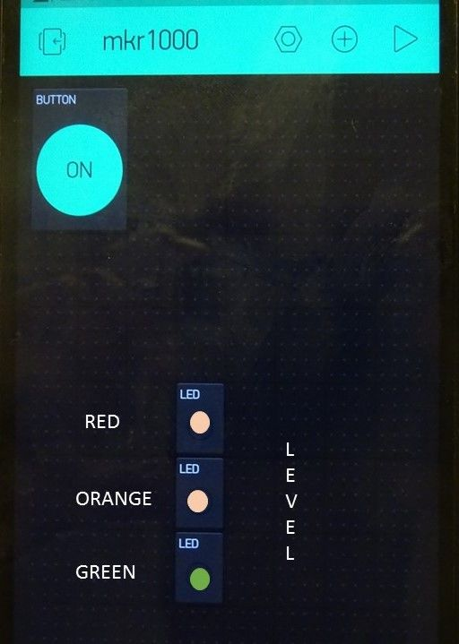
After having put 10% of trash and closing the bin we have the green LED that comes on the other two stay off.
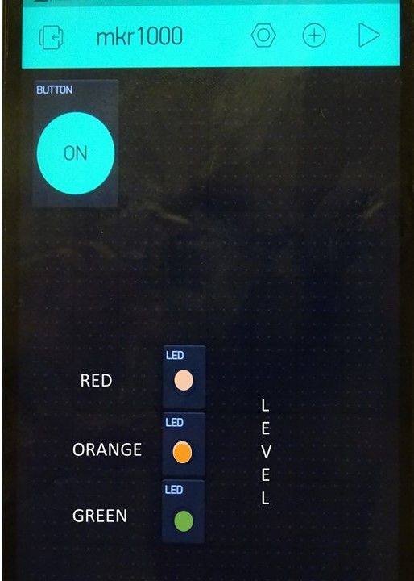
50% full...
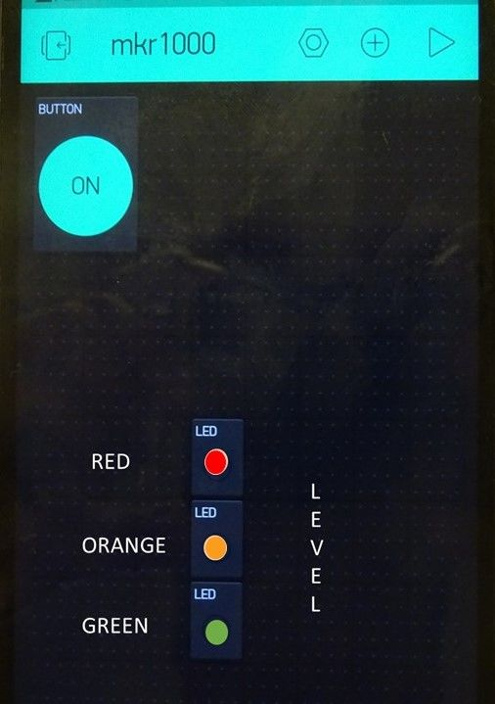
...and finally we put all the trash possible, and all three LEDs and a smile lit up! Congratulations the model works : )

